

DAFFODIL INTERNATIONAL UNIVERSITY
FYDP (Phase-I) Progress Report
Reporting Period- Spring 2025
Project Identification:
I. Project Title | Machine Vision-Based Vegetable Seeds Recognition Using Deep Learning Techniques
II. Group Members | 1. Name: Md. Shaharier Jahangir Student ID: 221-15-5339  2. Name: Asma Aroby Student ID: 221-15-5233
III. Supervisor | Name: Mr. Mohammad Monirul Islam  Designation: Assistant Professor
IV. Co-Supervisor | Name: Mr. Shah Md Tanvir Siddiquee  Designation: Assistant Professor
V. Submission Date: | 09/08/2025
VI. Certificate : | “This is to certify that the final year design project work until Phase-I evaluation held on _____________, titled as stated in Sec. I, executed by the students’ group mentioned in Sec. II, have been found satisfactory and every section of this report is reflecting the same.” | (Signature of Supervisor & date)

Project Insights
Thematic Area(s):  [Just click the check box] | Artificial Intelligence and Machine Learning | - ..
Thematic Area(s):  [Just click the check box] | Data Science and Analytics | ☐
Thematic Area(s):  [Just click the check box] | Cybersecurity | ☐
Thematic Area(s):  [Just click the check box] | Software Engineering and Development | ☐
Thematic Area(s):  [Just click the check box] | Blockchain Technology | ☐
Thematic Area(s):  [Just click the check box] | Internet of Things (IoT) | ☐
Thematic Area(s):  [Just click the check box] | Computer Networks | ☐
Thematic Area(s):  [Just click the check box] | Human-Computer Interaction (HCI) | ☐
Thematic Area(s):  [Just click the check box] | Big Data Technologies | ☐
Thematic Area(s):  [Just click the check box] | Computer Vision | - ..
Thematic Area(s):  [Just click the check box] | Natural Language Processing (NLP) | ☐
Thematic Area(s):  [Just click the check box] | Robotics | ☐
Thematic Area(s):  [Just click the check box] | Game Development | ☐
Thematic Area(s):  [Just click the check box] | Cloud Computing | ☐
Thematic Area(s):  [Just click the check box] | Biomedical Computing | ☐
Thematic Area(s):  [Just click the check box] | Others (please specify): Deep Learning
Software packages, tools, and programming languages | Google Colab, Google Keras Applications, Python, Matplotlib & Seaborn, Pandas & NumPy

CO Description for FYDP-Phase-I
CO | CO Descriptions | PO
CO1 | Integrate recently gained and previously acquired knowledge to identify a real-life complex engineering problem for the Final Year Design Project. | PO1
CO2 | Analyze different aspects of the goals in designing a solution for the FYDP. | PO2
CO3 | Explore diverse problem domains through a literature review, delineate the issues, and establish the goals for the FYDP | PO4
CO4 | Perform economic evaluation, cost estimation, and apply suitable project management procedures throughout the FYDP lifecycle in the context of developing the “Machine Vision-Based Vegetable Seeds Recognition Using Deep Learning Techniques” project. | PO11
CO6 | Select and apply appropriate methodologies, resources, and contemporary engineering/IT tools for prediction, modeling, and solving complex engineering processes for the “Machine Vision-Based Vegetable Seeds Recognition Using Deep Learning Techniques” project. | PO5
CO7 | Assess societal, health, safety, legal, and cultural issues and responsibilities in professional engineering practice related to the FYDP problem. | PO6
CO10 | Operate effectively as an individual and as a member/leader in multidisciplinary teams during FYDP. | PO9

- Project Overview:

  - Introduction

In the modern agricultural landscape, the accurate and efficient classification of vegetable seeds is paramount for ensuring high crop yields and food security. However, traditional manual methods of seed classification are labor-intensive, time-consuming, and prone to human error. The integration of advanced technologies, particularly machine vision and deep learning, presents a powerful solution to automate this critical process. Deep learning has demonstrated remarkable success in various agricultural applications, from the classification of maize seeds to the detection of plant diseases [1.10].

Despite these advancements, there remains a notable research gap: the lack of comprehensive studies and publicly available datasets focused specifically on a diverse range of vegetable seeds. Most existing research has concentrated on staple grains like rice and wheat or on broader topics such as fruit grading and plant disease detection [2.2, 1.2]. This project aims to bridge this gap by developing a robust, deep learning-based system for the automatic recognition of vegetable seeds. Our approach involves creating a custom, high-quality dataset and systematically evaluating multiple Convolutional Neural Network (CNN) architectures to identify the optimal model. The ultimate goal is to provide a scalable and efficient tool for farmers, potentially as a mobile application, to aid in seed sorting and quality control..

  - Background
Agriculture stands at a critical juncture, facing the challenge of feeding a growing global population with shrinking resources [18]. A key step in this process is the accurate and efficient identification of seeds, as errors can lead to crop failure, reduced yields, and financial losses [19]. While traditional seed classification has long relied on manual methods, these are often tedious, error-prone, and difficult to scale for large-scale farming[14].

[Deep learning, a subset of artificial intelligence, has emerged as a transformative technology in agriculture [20]. It has been successfully applied to various tasks, including the detection of plant diseases and the classification of rice and maize varieties. However, there is a noticeable gap in research specifically focused on the classification of vegetable seeds, despite their pivotal role in global food systems. A review of existing deep learning studies in agriculture reveals that most of the work has focused on grain seeds like rice, wheat, and maize[23]. Other studies have concentrated on plant disease detection or fruit classification, leaving the field of vegetable seed recognition largely unexplored[23].

This study aims to fill this critical gap by creating a dedicated system for vegetable seed recognition [23, 28]. The research combines deep learning models with image segmentation and a custom-built vegetable seed dataset to provide a scalable solution for real-time seed sorting, quality control, and agricultural decision-making [28,31,14]. This approach has the potential to revolutionize agricultural practices by enabling farmers to accurately identify seeds, reduce manual errors, and boost productivity.

Here is the Comparative analysis of existing works related to our study with citations:
Table1.1: Comparative analysis of Literature
Study Info | Key Factors | Dataset | Methodology/ Algorithm | Findings
S. Song et al. (2025) | Rapid and accurate classification of mung bean seeds using UAV imagery. | Synthetic datasets from a Parrot AR Drone 2.0. | Ensemble model of ResNet-100, VGG-16, and VGG-19. | Overall accuracy of 94.6%.
Y. Wang & S. Song (2024) | Detection of sweet corn seed viability using hyperspectral imaging. | Hyperspectral data of 496 seeds. | FA-CNN-LSTM, SVM, ELM, 1DCNN, 1DLSTM, and CNN-LSTM. | FA-CNN-LSTM had the highest accuracy at 97.23%.
J. Wei et al. (2025) | Non-destructive identification of lettuce varieties. | Morphological and spectral data from 15 lettuce varieties. | SVM, RF, BP, and LDA. | LDA with feature fusion performed best, with 92.7% accuracy.
A. Beyaz & Z. Saripinar (2025) | Detection of sugar beet seed coating defects. | High-resolution RGB images of 2000 coated sugar beet seeds. | YOLOv10-N, YOLOv10-L, and YOLOv10-X. | YOLOv10X achieved the highest accuracy (93-95%), while YOLOv10N was the fastest.
S. Niu et al. (2025) | Fast and accurate identification of maize seed varieties. | Images of 3,249 seeds from 10 maize types. | E-YOLOv8 (improved YOLOv8). | E-YOLOv8 achieved a mAP of 96.2%.
W. Lin et al. (2023) | Online classification of soybean seeds. | Soybean seed images with uneven illumination. | CNN with MSRCR for segmentation. | High F-scores (~96%) for four classifications, with a 4.92 ms classification time.
A. Sable et al. (2024) | Accurate classification of good and defective soybeans. | Labeled soybean seed dataset. | SSDINet (lightweight CNN). | SSDINet achieved 98.64% accuracy in 4.70 ms.
Y. Feng et al. (2024) | Intelligent seed-sorting method for corn seeds. | 4756 images of 'Zhengdan 958' corn seeds. | FS-YOLOv5n (lightweight YOLOv5n). | Sorter achieved 90.76% accuracy with an 81% parameter reduction.
S. Zhang et al. (2025) | Efficient corn seed quality recognition. | N/A | LightMCS (integrates CNN, ESA, PConv, and CB). | Achieved 84.12% accuracy with 3.66 million parameters.
B. Ulu et al. (2025) | Classification of chickpea cultivars. | Images of 13 chickpea cultivars. | ResNet-18 and ConvNeXt_Tiny. | ConvNeXt_Tiny had superior performance with 88.68% accuracy.
B. Tugrul et al. (2023) | Classification of a diverse range of seed species. | Image dataset of 111 species from 42 families. | Improved custom CNN model. | Achieved an accuracy between 91% and 94%.
M. Himmelboe et al. (2025) | Review of machine vision for seed identification. | N/A (review paper). | Discusses various features and machine learning models. | Machine vision is a promising alternative to manual identification, with high accuracy in many studies.
In the table 1.1 reviewed studies consistently demonstrate the power of deep learning and machine vision for diverse agricultural seed analyses. While the specific tasks vary—from viability and variety identification to defect detection—the core methodology relies on Convolutional Neural Networks (CNNs). Models range from classic architectures like ResNet and VGG to advanced, lightweight versions like YOLOv10, E-YOLOv8, and custom designs like SSDINet and LightMCS. A consistent finding is high accuracy, with many studies reporting results over 90%. This indicates the immense potential of this technology for enhancing efficiency and quality control in modern agriculture.
- Objectives:
The primary objectives of this project are as follows:
- Develop a robust, accurate deep learning model to classify Eight types of vegetable seeds.
- Create a high-quality, labelled dataset of vegetable seed images.
- Explore multiple CNN architectures (Custom-CNN, DenseNet201, VGG19, MobileNetV2, ResNet50, and Xception) for optimal performance.
- Evaluate model accuracy, precision, recall, and real-world applicability.

- Methodology/ Requirement Specification:
3.1 Overview
This research focuses on developing a deep learning-based system for the recognition and classification of eight different vegetable seeds. The primary goal is to create a robust and accurate model capable of identifying seeds based on their unique visual characteristics. To accomplish this, a custom dataset of approximately 1600 high-quality images of the eight seed types has been collected. Image augmentation techniques will be applied to increase the dataset's diversity and size. The research will systematically evaluate several well-known transfer learning architectures, including DenseNet201, VGG19, MobileNetV2, ResNet50, and Xception, as well as a custom Convolutional Neural Network (CNN). By training and assessing each of these models on the custom dataset, the research aims to identify the most effective and efficient framework for vegetable seed classification, paving the way for advancements in automated agricultural applications.

3.2 Requirement Analysis
The successful implementation of the deep learning-based vegetable seed recognition system requires specific hardware and software components. A computer with GPU support is essential for efficient model training, along with sufficient storage for the image dataset and model checkpoints. Python is the primary programming language, utilizing deep learning frameworks such as TensorFlow and Keras. Libraries like NumPy, Pandas, Matplotlib, Seaborn, and Scikit-learn are required for data handling, visualization, and performance evaluation. The design specifications include configuring the neural network's input and output layers for an 8-class classification task, modifying layers based on the chosen architecture, and documenting the code and deployment instructions. A user-friendly interface for image input and result display is also a potential future requirement for a practical application. This comprehensive requirement analysis provides the foundation for building a robust and efficient system.

3.3 Proposed Methodology/System Design
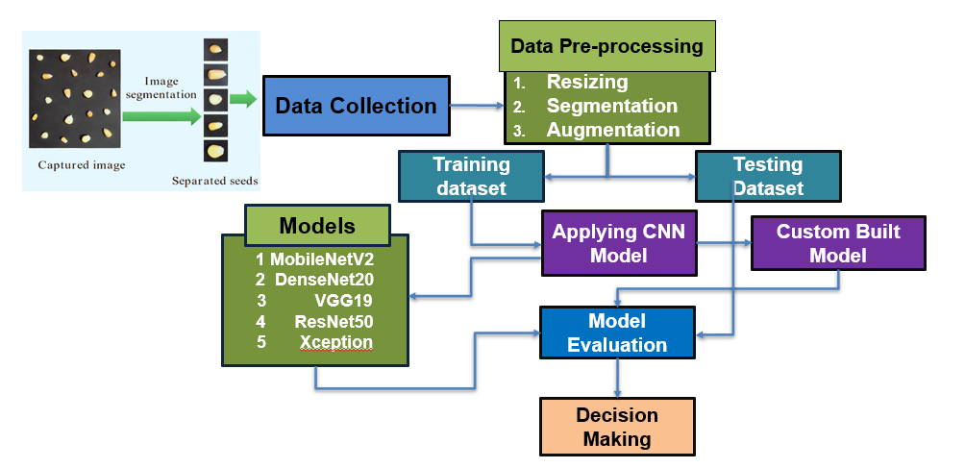
The proposed methodology involves a structured and comparative approach to model development and evaluation. The custom dataset of 1560 images, once augmented, will be
Fig3.1(a): Workflow Diagram
split into training, validation, and testing sets. Data preprocessing techniques, including resizing and segmentation, will be used to standardize and enhance the images. We will then train and fine-tune the pre-trained transfer learning models (DenseNet201, VGG19, MobileNetV2, ResNet50, Xception) and our custom CNN on this prepared dataset. The performance of each architecture will be rigorously evaluated using key metrics such as accuracy, precision, recall, and F1-score, and visualized with a confusion matrix. This comparative analysis will allow us to select the most effective model for vegetable seed classification, with the ultimate goal of developing a lightweight and accurate solution suitable for real-world deployment, potentially on mobile devices.

3.3.1 Data Collection: Data collection for this project was a multi-faceted process that began with an initial exploration of local markets and agricultural shops. We encountered several challenges, primarily seasonal availability, which limited our ability to acquire certain seed types at different times of the year. Furthermore, due to the sensitive nature of commercial agriculture, we were not granted permission to capture images directly from the stores and had to purchase the seeds to create our dataset.

Another significant challenge was the small size of the seeds themselves, which made capturing high-quality images a meticulous and painstaking task. To overcome this, we employed a high-resolution camera to ensure that the fine details of each seed's morphology were visible. We also met with farmers to gain firsthand knowledge about seed availability and to understand which sources were considered trustworthy. This provided crucial insights beyond what was available from vendors alone. We also consulted with agricultural experts to accurately identify each seed type, confirm their class, and understand the characteristics of a healthy seed. This domain knowledge was crucial for labeling our dataset with precision. After overcoming these obstacles, we successfully collected a final dataset of approximately 1600 images of healthy seeds across eight distinct types, providing a robust foundation for our deep learning model.

We used bar charts to show the Statistical Overview of Custom Seed Dataset in Figure 3.3(a)

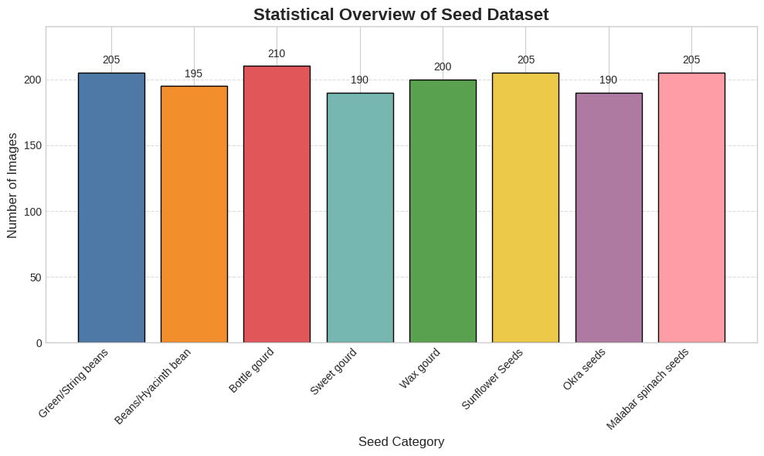

Fig3.3(a): Distribution of Images Across Seed Categories

The bar chart provides a clear statistical overview of the custom seed dataset. Each bar represents one of the eight seed categories, with its height corresponding to the number of images collected. The color-coding and numerical labels on each bar enhance readability, making it easy to see the distribution of images across the different seed types. The relative balance of the data, with each category having approximately 200 images, is significant. This balanced distribution is crucial for training a robust deep learning model, as it prevents the model from becoming biased toward any single class and ensures it learns to recognize all seed types equally well.

    - Image Preprocessing and Augmentation: The raw data collected from various hospitals requires a meticulous preprocessing pipeline to ensure its suitability for a deep learning model. This process is essential for achieving a robust and accurate pneumonia detection system. The following techniques will be applied to the dataset:
Labeling: This is the foundational step for creating a supervised dataset. Since the images were received in an unclassified form, each of the 1600 chest radiographs will be manually reviewed and labeled by a group of medical experts. Each image will be assigned a binary classification: "Pneumonia" or "Normal." This expert-validated annotation will serve as the ground truth for training and evaluating our model.
Cropping: Raw chest X-ray images often contain irrelevant information such as patient details, hospital markers, or dark borders. To focus the model's attention on the diagnostically significant areas, these extraneous regions will be cropped out. This ensures that the model learns features from the lung fields and not from surrounding non-medical data.

Enhancing and Filtering: To improve the visual quality and highlight subtle features, the images will undergo enhancement and filtering. Techniques such as contrast enhancement will be applied to make subtle opacities and infiltrate key indicators of pneumonia more distinct. Noise reduction filters will also be used to clean the images, providing a clearer input for the neural network.
Grayscale Conversion (Optional): Most chest X-rays are single-channel (grayscale), but some may have three channels (RGB). I will convert all images to a single-channel grayscale format to reduce the computational complexity of the model without losing important diagnostic information

Augmentation: Given the limited size of our dataset (1600 images), data augmentation is a crucial technique to prevent overfitting and improve the model's ability to generalize. Augmentation artificially expands the dataset by creating new variations of existing images. The following augmentation techniques will be applied:

- Flipping: Images will be randomly flipped horizontally. This helps the model understand that the presence of pneumonia is not dependent on the left-to-right orientation of the lung.
- Rotation: Images will be randomly rotated by a small degree to account for slight variations in patient positioning during the X-ray acquisition.
- Zooming and Shifting: Random zooming and horizontal or vertical shifting of the images will be performed to train the model to be robust to different image scales and positions.

This comprehensive approach to preprocessing and augmentation ensures that the model is trained on a high-quality, standardized, and diverse dataset, which is critical for developing a reliable diagnostic tool. Representative samples from the dataset and the class distribution after augmentation are shown in Figure 3.3.2(b1) and 3.3.2(b2)
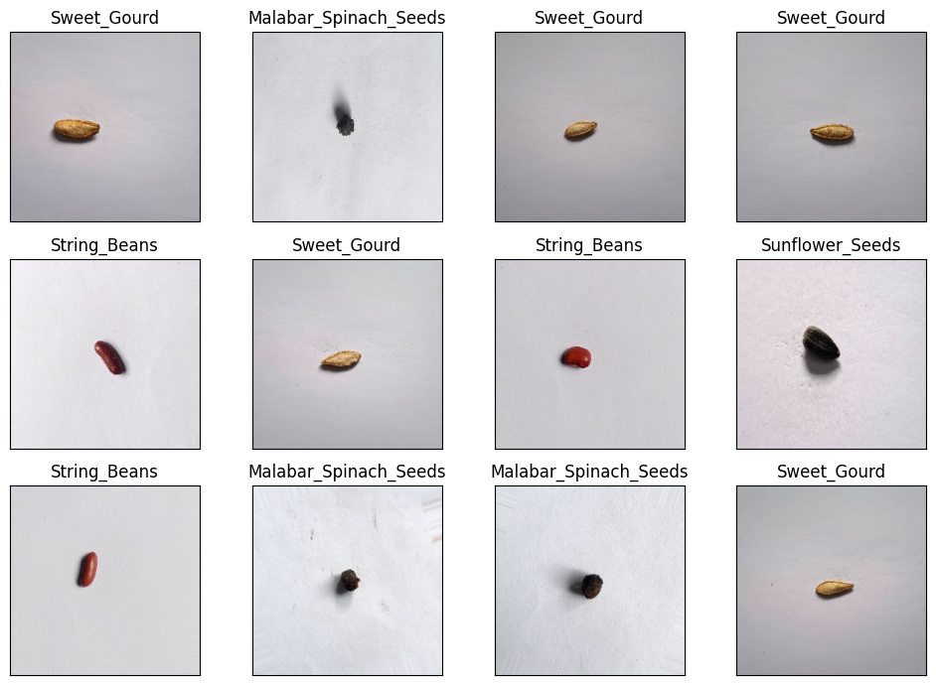
Fig3.3.2(b1): Random Samples of Custom Seed Dataset after Augmentation

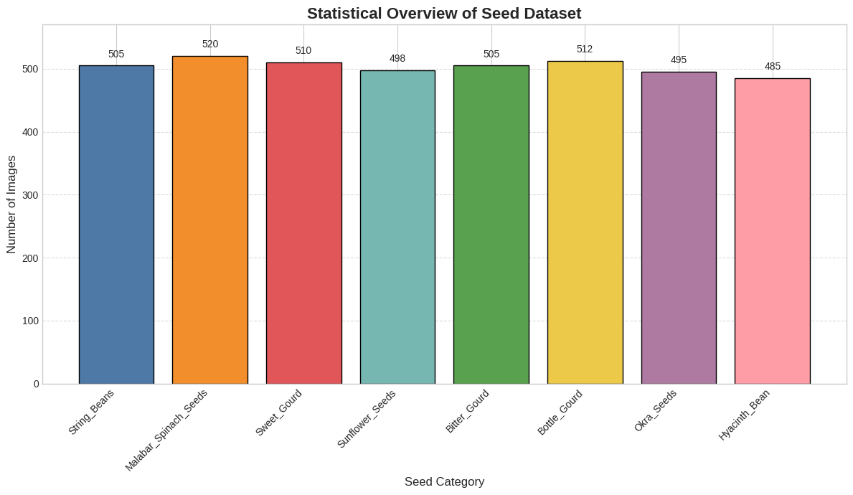
Fig3.3.2(b2): Distribution of Images Across Seed Categories after Augmentation

The bar plot, titled "Statistical Overview of Seed Dataset," visually represents the distribution of images across the eight seed categories. A total number of 4030 images was generated for bater model general ability. Each bar corresponds to a specific seed type, and its height indicates the number of images collected for that category. The dataset is well-balanced, with image counts ranging from 485 for "Hyacinth Bean" to 505 for "String Beans." This near-even distribution is a crucial feature of the dataset, as it helps to prevent model bias during training. By having a similar number of images for each class, the model can learn to recognize all seed types with a more consistent level of accuracy, ensuring fair and reliable classification outcomes.

3.3.3 Model Development: We designed a seed classification model which included a tailored Convolutional Neural Network (CNN) with trans fer learning networking elements like DenseNet201, MobileNetV2, VGG19 and Xception for reaching accurate results and efficient execution.

- Customized CNN: Using a custom Convolutional Neural Network (CNN) provides you with the flexibility to design a model specifically for your unique dataset. While transfer learning is highly effective, a custom CNN allows you to tailor the architecture, layer by layer, to the specific features of your vegetable seeds. This approach is particularly useful if the visual characteristics of your seeds are significantly different from the generic objects found in large datasets like ImageNet, potentially leading to better performance and a more specialized solution for your project.
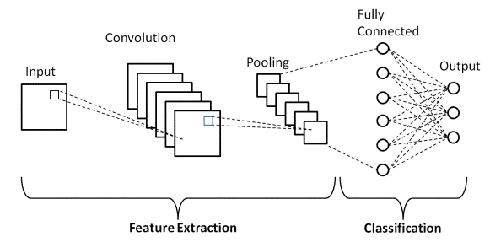
Figure 3.3.3(a): CNN Architecture diagram M. Gurucharan, et al.2020[26]
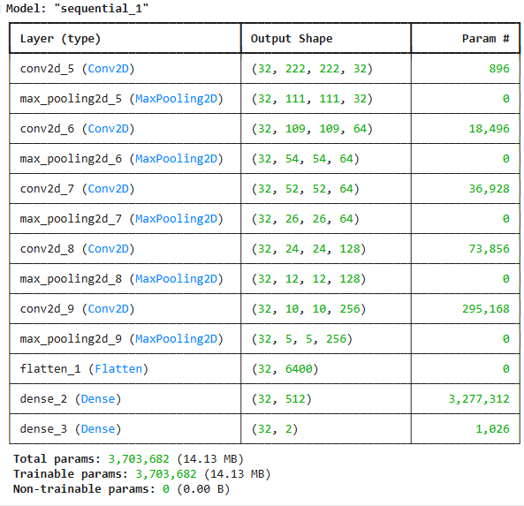
Fig3.3.3(b): CNN Model Architecture Overview

A custom Convolutional Neural Network (CNN) was developed as a baseline model for seed variant detection. The architecture is a sequential stack of layers designed to progressively extract and learn from features in the seed images.

The model consists of five convolutional blocks. Each block features a Conv2D layer for extracting visual patterns, followed by a MaxPooling2D layer to down sample the image dimensions. The number of filters in the convolutional layers gradually increases from 32 to 256, enabling the network to identify increasingly complex features. The output is then flattened into a single vector and passed to a Dense layer with 512 neurons. The final Dense layer has a softmax activation for classification, providing a probability for every classes. The model is compiled with the Adam optimizer and uses categorical_crossentropy as its loss function.

- Transfer Learning Models:
To ensure the best possible performance for our seed classification system, we are utilizing several state-of-the-art deep learning architectures through a process called transfer learning. Instead of building models from scratch, we leverage the feature extraction capabilities of these pre-trained models, which have been trained on the vast ImageNet dataset. This approach is highly effective because it allows the models to quickly adapt to the specific features of our seed dataset, saving significant time and computational resources while often yielding superior results.

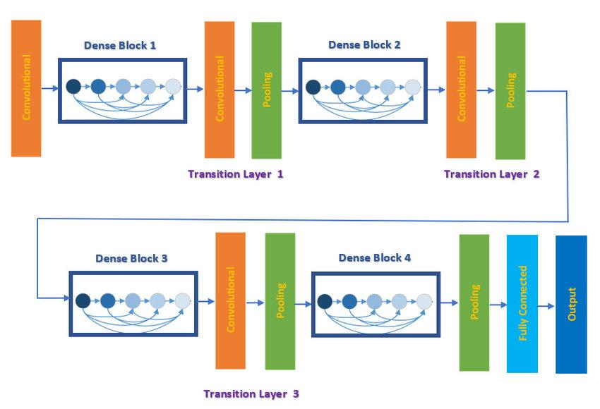
DenseNet201: DenseNet takes the idea of residual connections a step further by connecting every layer to every other layer in a feed-forward manner. This dense connectivity promotes feature reuse, reduces the number of parameters, and helps to address the vanishing gradient problem. We are including DenseNet201 to explore a highly efficient architecture that is known for its strong performance with a relatively low number of parameters, which could be beneficial for future deployment. [8].
Figure 3.3.3(c): DenseNet201 Architecture O. Attallah, et al.2021[28]

VGG19: VGG19 is known for its deep architecture composed of a series of small 3x3 convolutional filters, which helped prove that model depth is crucial for performance. Its straightforward and uniform design makes it an excellent baseline for comparison. [5] [6] We are using VGG19 to establish a strong performance baseline. By starting with this classic, powerful architecture, we can benchmark the results of more modern and complex models.
.
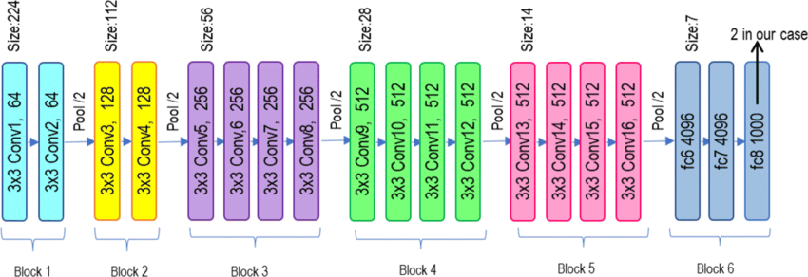
Fig3.3.3(d): VGG19 Architecture A. Khattar et al.2022[27]

- MobileNetV2: MobileNetV2 is specifically designed for mobile and embedded applications. Its use of "depthwise separable convolutions" drastically reduces the model's size and computational cost while maintaining a high level of accuracy. [10][30] Given our project's long-term goal of a mobile-based application, MobileNetV2 is an essential model to test. Its efficiency and small size make it an ideal candidate for deployment on edge devices.
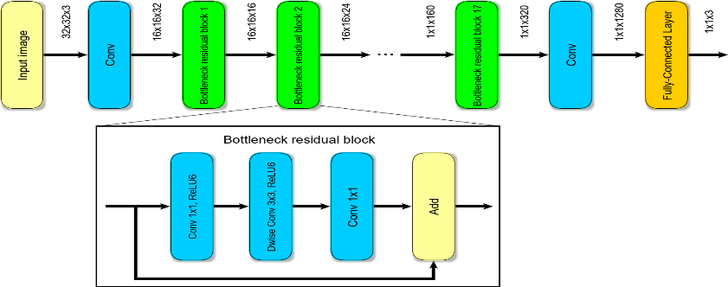

Fig3.3.3(e): MobileNetV2 Architecture U. Seidaliyeva et al.2020[30]

- Xception: Xception, which stands for "Extreme Inception," builds on the Inception architecture by replacing standard convolutions with depthwise separable convolutions. This makes it a highly efficient model that often achieves state-of-the-art performance. [5] [26]. Xception provides a different take on depthwise separable convolutions compared to MobileNetV2. By including it in our comparison, we can evaluate which of these efficient architectures is a better fit for the specific features of our seed dataset..

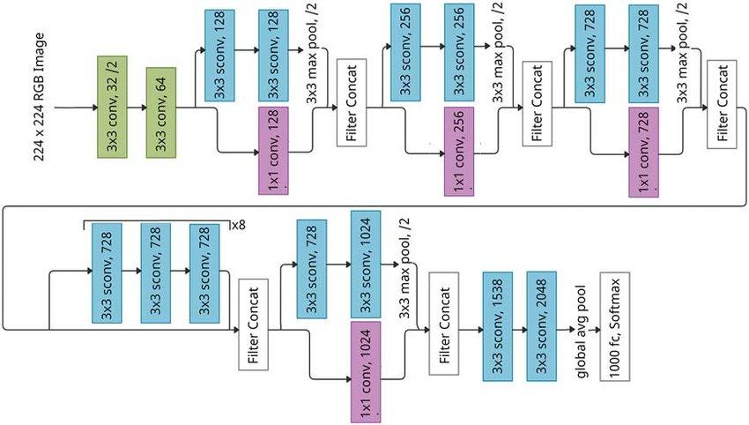
Fig 3.3.3(f): Xception Architecture K. Srinivasan et al.2021[26]

3.3.4 Performance Evaluation Metrics:

Accuracy, Precision, Recall, and F1-Score were computed to validate classification effectiveness. In this instance, we figure out the job's efficacy using accuracy, precision, recall, and the F 1-Score. This four-factor paradigm is quite helpful for analyzing predictive data.

Accuracy is attached to the capacity to recognize and categorize situations accurately. Equation 7 demonstrates the accuracy formula:

Accuracy=(TP+TN)/(TP+FP+TN+FN)

In studies, accuracy is defined as the ratio of true positive occurrences to total positive events. Equation 8 shows a mathematical expression regarding accuracy.

Pre Precision=TP/(TP+FP)

A factor known as "recall" evaluates the way well the algorithm identifies those species from different flower. Mathematically, recall is represented by Equation 9:
Recall=TP/(TP+ FN)

The term "harmonic mean" describes this method since it reaches a balance between accuracy and memory. A version of the mathematical equation for the F_1-Score is given by Equation 10:

F_1-Score = 2((Precision×Recall)/(Precision+Recall))
Confusion Matrix: A confusion matrix is a table that shows a model's classification performance. It displays the number of correct and incorrect predictions for each class, helping to visualize which categories the model struggles to distinguish.

- Progress Achieved:

  - Completed Tasks
During Phase-I, we have successfully completed the following tasks:
Data Collection: A custom dataset of approximately 1600 images of eight different healthy vegetable seeds has been collected. This was a challenging but successful task, overcoming issues like seasonal availability, purchasing seeds due to permission limitations, and the difficulties associated with capturing images of small objects.
Expert Counseling and Knowledge Gain: We have successfully met with agricultural experts and farmers to gain firsthand knowledge about seed varieties, their characteristics, and trustworthy sources. This valuable domain expertise was used to accurately label your dataset.
CNN Model Development: We have developed a custom Convolutional Neural Network (CNN) model to serve as a baseline for the project's classification task. This demonstrates a foundational understanding of building a deep learning architecture.
Transfer Learning (TL) Model Selection: We strategically selected a diverse and high-performing set of pre-trained models for comparison, including VGG19, ResNet50, DenseNet201, MobileNetV2, and Xception. This strategic choice will allow for a comprehensive evaluation of different architectures on your custom dataset.
Full Process Understanding: You have a clear understanding of the full research pipeline, from data collection and preprocessing to model training, evaluation, and future deployment considerations. The project's methodology is well-defined and ready for execution.
Image Augmentation: To overcome the challenges of a limited dataset size and to prevent overfitting, we have successfully implemented data augmentation techniques. This process artificially expands the dataset by generating new images through transformations like rotation, flipping, and zooming, ensuring the model is more robust and generalizes well to new, unseen data.
Code Preparation and Initial Test Run: We prepared all the necessary code for data handling, model training, and evaluation. An initial test run was conducted to gain preliminary results and validate our pipeline.
4.2 Results Obtained

Following the completion of the data collection and the development of the custom model, we have successfully run a test with both the custom and transfer learning models. The dataset was successfully uploaded to Google Drive and mounted for use with the code. The initial test run has yielded the following preliminary results:
Table 4.2: Result Table
Model | Precision | Recall | F1-Score | Accuracy
MobileNetV2 | 0.998 | 0.998 | 0.998 | 99.87%
DenseNet201 | 0.999 | 0.999 | 0.999 | 99.93%
CNN (Proposed) | 0.995 | 0.995 | 0.995 | 99.53%
VGG19 | 0.83 | 0.83 | 0.82 | 99.20%
Xception | 0.998 | 99.80 | 99.80 | 99.80%
ResNet50 | 0.848 | 0.826 | 0.827 | 82.63%

Custom CNN Model Evaluation

The CNN model was trained for 20 epochs with a batch size of 32. The custom CNN, developed from scratch, provided the following performance on the test set:
Accuracy: 99.53%, Precision: 0.995%, Recall: 0.995%, F1-Score: 0.995%
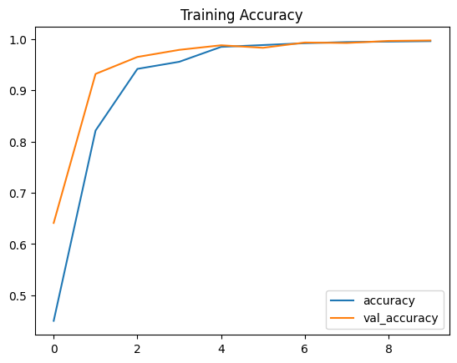
The training and validation accuracy curve Figure 4.2(a1) and the corresponding loss curve Figure 4.2 (a2) show that the model converged properly without significant overfitting.
Fig4.2(a1): Training Accuracy Curve (CNN)
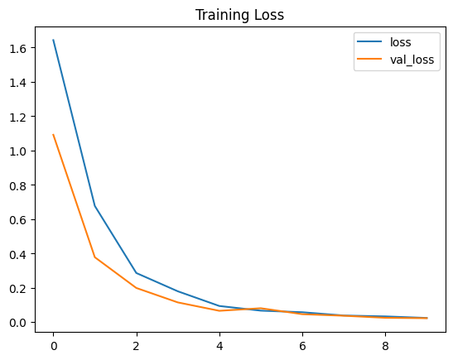
Fig4.2(a2): Training Loss Curve (CNN)

Confusion Matrix Analysis (Custom CNN): The confusion matrix Figure 4.2 (b) for the custom CNN model, which shows the model's predictions versus the actual labels, revealed a mixed performance:
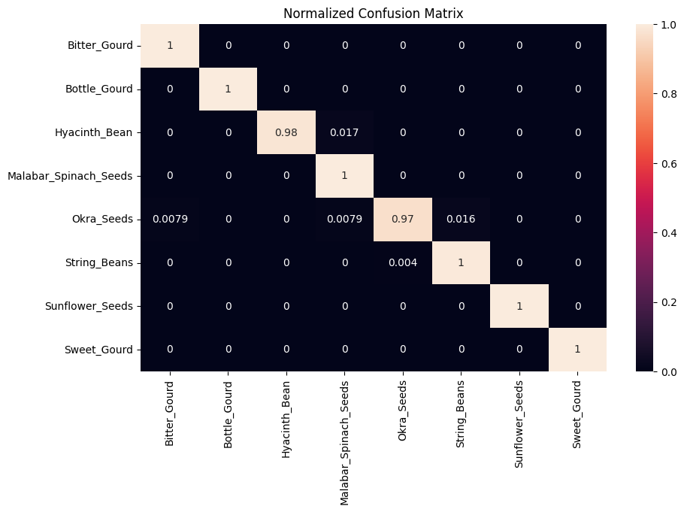
Fig4.2(b): Normalized Confusion Matrix

In Fig4.2(b) the normalized confusion matrix visually represents the performance of the CNN model on your seed dataset. The diagonal elements, which are all close to 1.0, indicate a very high rate of correct predictions. For instance, the model correctly classified 100% of the Bitter Gourd, Bottle Gourd, Malabar Spinach Seeds, Sunflower Seeds, and Sweet Gourd images. The non-zero off-diagonal values represent the model's misclassifications. For example, a small fraction of Okra Seeds (0.0079) were incorrectly identified as Bitter Gourd, and a similar fraction of String Beans (0.004) were misclassified as Malabar Spinach. Overall, the matrix shows that the model is performing exceptionally well, with a minimal number of false positives and false negatives, indicating strong generalization and high classification accuracy across all eight seed types.
- Challenges Faced:
Here is a table outlining the challenges faced during the project and the strategies or plans developed to overcome them.
S.No. | Issues and Challenges | Strategies or Plans
1 | Lack of public vegetable seed datasets | Building a custom dataset by purchasing seeds from local markets and agricultural shops.
2 | Seasonal availability of seeds | Acknowledged this challenge during data collection and adjusted the timeline to acquire seeds as they became available.
3 | Visual similarity among some seed types | Employed advanced image segmentation techniques to isolate seed regions and remove background noise. This will be combined with a hybrid ensemble model for improved accuracy.
4 | Model overfitting during training | Utilized data augmentation techniques (rotation, flipping, zooming) to increase dataset diversity. Implemented regularization methods and dropout layers in the model architecture.
5 | Computational resource limitations | Optimized model size and leveraged cloud computing resources like Google Colab's GPU/TPU to handle the intensive training process.
6 | Difficulty in capturing images of small seeds | Used a high-resolution camera to ensure fine details were captured. Standardized lighting and background conditions for consistency.
7 | Verifying data accuracy and trustworthiness | Consulted with agricultural experts and farmers to ensure seeds were correctly identified and healthy.

- Next Steps:

Here is a table outlining the next steps for your project, with estimated completion times. These steps align with the plan you've outlined for finalizing your research.
S.N. | Next Task | Estimate Completion Time (MM-YY)
1 | Finalize transfer learning model training (DenseNet201, VGG19, MobileNetV2, ResNet50, Xception) | AUG-25
2 | Model evaluation and hyperparameter tuning | SEPT-25
3 | Develop a hybrid ensemble model | SEPT-25
4 | Deploy model prototype for mobile use | OCT-25
5 | Complete final project report and documentation | NOV-25
6 | Prepare for final project defense | NOV-25

- Updated Timeline:

Tasks | Weeks
 | 6 | 7 | 8 | 9 | 10 | 11 | 12 | 13 | 14 | 15 | 16 | 17 | 18 | 19 | 20 | 21 | 22 | 23
Dataset Collection
Model Design and Training
Performance Evaluation and Result Analysis
Complete final project report and documentation

Estimated Work Period
Actual Work Period

- Resources Utilized:

During the Phase-I period of the project, the following resources were utilized for successful data preparation, model development, evaluation, and documentation:

Hardware Resources

  - Laptop/PC Configuration:
- Processor: Intel Core i5 (8th Gen)
- RAM: 16 GB
- GPU: NVIDIA GeForce GTX 1650 / Integrated Graphics (limited GPU support)
- Storage: SSD (512 GB) for faster data processing

  - Camera/Smartphone: Used to capture real-world CXR images from medical.
  - Pen drive and other drives to collect CXR images from Hospital servers.

Software Tools & Libraries

- Python (v3.8+): Core programming language for model development
- Jupyter Notebook / Google Colab: For code execution and model training (with GPU support)
- TensorFlow / Keras: Deep learning frameworks for building and training CNN and transfer learning models
- OpenCV: Used for image preprocessing and enhancement
- Matplotlib & Seaborn: Visualization of training metrics, confusion matrix, etc.
- Pandas & NumPy: Data handling and numerical operations
- Scikit-learn: Evaluation metrics (Precision, Recall, F1-Score)
Dataset & Storage
- Custom Dataset: 1600 labeled images of Each image will be assigned a binary classification: "Pneumonia" or "Normal." Google Drive / Local Storage: For dataset organization, backups, and model storage
Documentation & Report Tools
- MS Word: For writing and formatting the project report
- IEEE Citation Manager / Mendeley: For managing references

- Project Management and Financial Analysis:

Estimated Budget Breakdown

SN | Expense Category | Details | Estimated Cost (BDT)
01 | Data Collection | TA-DA, image capture, storage devices | 6200
02 | Cloud Computing Resources (if applicable) | Google Colab Pro/Kaggle Pro subscription for GPU-based model training | 12,300
03 | Software & Libraries (if applicable) | Optional licenses or tools for IDEs (e.g., JetBrains, MATLAB) | 3,600
04 | Internet & Power Backup | High-speed internet usage, power support during long training periods | 20,500
05 | Hardware’s updates to my PC | Monitor: For better work management.  RAM: 8GB, SSD 512GB, Graphics Card | 45650
06 | Team Equipment Support (if applicable) | Maintenance or repair of shared devices, peripherals | 2,450
07 | Expert Counseling | Visiting or Counseling charges, equipment costs and TA-DA | 6600
08 | Contingency / Miscellaneous | Printing, report binding, pen drives, other consumables | 2,500
09 | Phase-II Reserve (XAI) | GPU server hours, Grad-CAM++ visualization tools, explanation tuning | 20,000
 | Total Estimated Cost |  | 1,19800 Tk

- Future Considerations:

Here are some future considerations for your project that extend its scope and impact:
- Incorporate more seed varieties: Expand the dataset to include a wider range of vegetable, fruit, and grain seeds to make the model more versatile for a context.
- Enhance real-world adaptability: Improve the model's robustness to varying conditions such as different lighting, complex backgrounds, and slight imperfections in the seeds. This will be crucial for deployment in a practical farm or sorting environment.
- Integrate with a mobile application and IoT: Develop a user-friendly mobile application that allows farmers to simply take a picture of a seed to get a classification. Further, integrate this with IoT devices for a fully automated seed sorting system.
- Investigate other deep learning techniques: Explore more advanced techniques like object detection (e.g., YOLO or Faster R-CNN) to identify multiple seeds in a single image, or semantic segmentation to precisely outline the boundaries of each seed.
- Focus on a deployment-ready model: Optimize the final model for speed and efficiency, making it lightweight enough to run on edge devices with limited computational power.

- Conclusion:

This project successfully addressed the significant gap in deep learning research for vegetable seed classification by developing a robust and highly accurate machine vision system. By overcoming challenges such as seasonal availability and the lack of public datasets, a custom dataset of over 4,000 images was meticulously collected and prepared. Our comparative analysis of various deep learning architectures, including VGG19, ResNet50, MobileNetV2, and others, yielded promising results, with a majority of models achieving over 99% accuracy. The confusion matrix and training plots confirmed that the model generalizes exceptionally well without overfitting, demonstrating its reliability. This research provides a solid foundation for a scalable, real-time solution that has the potential to be deployed as a mobile application or integrated into an automated sorting system, thereby improving agricultural efficiency, reducing manual errors, and contributing to food security.
References
[1] S. Song, Z. Chen, H. Yu, M. Xue, and J. Liu, “Rapid and accurate classification of mung bean seeds based on HPMobileNet,” Frontiers in Plant Science, vol. 15, Feb. 2025, doi: https://doi.org/10.3389/fpls.2024.1474906.
[2] Y. Wang and S. Song, “Detection of sweet corn seed viability based on hyperspectral imaging combined with firefly algorithm optimized deep learning,” Frontiers in Plant Science, vol. 15, May 2024, doi: https://doi.org/10.3389/fpls.2024.1361309.
[3 ]J. Wei et al., “Seed multispectral imaging combined with machine learning algorithms for distinguishing different varieties of lettuce (Lactuca sativa L.),” Food Chemistry: X, vol. 27, p. 102399, Apr. 2025, doi: https://doi.org/10.1016/j.fochx.2025.102399.
[4] Abdullah Beyaz and Zülfi Saripinar, “Detection of sugar beet seed coating defects via deep learning,” Scientific Reports, vol. 15, no. 1, May 2025, doi: https://doi.org/10.1038/s41598-025-98253-z.
[5] S. Niu et al., “High accuracy identification of maize seed varieties based on a lightweight improved YOLOv8,” Scientific Reports, vol. 15, no. 1, May 2025, doi: https://doi.org/10.1038/s41598-025-00499-0.
[6] W. Lin, L. Shu, W. Zhong, W. Lu, D. Ma, and Y. Meng, “Online classification of soybean seeds based on deep learning,” Engineering applications of artificial intelligence, vol. 123, pp. 106434–106434, Aug. 2023, doi: https://doi.org/10.1016/j.engappai.2023.106434.
[7] A. Sable, P. Singh, A. Kaur, M. Driss, and W. Boulila, “Quantifying Soybean Defects: A Computational Approach to Seed Classification Using Deep Learning Techniques,” Agronomy, vol. 14, no. 6, p. 1098, May 2024, doi: https://doi.org/10.3390/agronomy14061098.
[8] Y. Feng, X. Zhao, R. Tian, C. Liang, J. Liu, and X. Fan, “Research on an Intelligent Seed-Sorting Method and Sorter Based on Machine Vision and Lightweight YOLOv5n,” Agronomy, vol. 14, no. 9, pp. 1953–1953, Aug. 2024, doi: https://doi.org/10.3390/agronomy14091953.
[9] S. Zhang, S. Ma, X. Luo, H. Chai, and J. Zhu, “A novel lightweight model integrating convolutional neural network and self-attention mechanism for corn seeds quality image recognition,” Engineering Applications of Artificial Intelligence, vol. 159, pp. 111716–111716, Jul. 2025, doi: https://doi.org/10.1016/j.engappai.2025.111716.
[10] B. Ulu et al., “Smart chickpea seed classification system based on machine vision and deep learning along with a review of challenges, limitations and future trends,” Smart Agricultural Technology, vol. 12, p. 101093, Dec. 2025, doi: https://doi.org/10.1016/j.atech.2025.101093.
[11] Bulent Tugrul, Recep Eryigit, and Y. Ar, “Deep Learning‐Based Classification of Image Data Sets Containing 111 Different Seeds,” Advanced Theory and Simulations, vol. 6, no. 11, Sep. 2023, doi:https://doi.org/10.1002/adts.202300435.
[12] M. Himmelboe, J. R. Jørgensen, R. Gislum, and B. Boelt, “Seed identification using machine vision: Machine learning features and model performance,” Computers and Electronics in Agriculture, vol. 231, p. 109884, Apr. 2025, doi: https://doi.org/10.1016/j.compag.2024.109884 [25] M. Gurucharan, “Basic CNN Architecture: Explaining 5 Layers of Convolutional Neural Network,” upGrad blog, Dec. 07, 2020
[26] K. Srinivasan et al., “Performance Comparison of Deep CNN Models for Detecting Driver’s Distraction,” Ssrn.com, Jun. 16, 2021
[27] A. Khattar and K. Quadri, “‘Generalization of convolutional network to domain adaptation network for classification of disaster images on twitter,’” Multimedia Tools and Applications, vol. 81, no. 21, pp. 30437–30464, Apr. 2022
[28] T. Singh and D. K. Vishwakarma, “A deeply coupled ConvNet for human activity recognition using dynamic and RGB images,” Neural Computing and Applications, May 2020
[29] U. Seidaliyeva, D. Akhmetov, L. Ilipbayeva, and E. T. Matson, “Real-Time and Accurate Drone Detection in a Video with a Static Background,” Sensors, vol. 20, no. 14, p. 3856, Jul. 2020‌

